

**SAFETY DATA SHEET**

***Company Information:***

BioBlend Renewable Resources, LLC

1500 Jarvis Ave.

Elk Grove Village, IL 60007 (630) 227-1800

[www.bioblend.com](http://www.bioblend.com/)

***Emergency Contact Information:***

**(630) 227-1800**

**8 AM - 4 PM, Monday through Friday**

Product Name

TruGear FG 320

Product Description

Food Grade Extreme Pressure Gear Oil

Product Use

Product is intended for use as an industrial lubricant.

This chemical is not considered hazardous by the 2012 OSHA Hazard Communication Standard, which has been updated to align with the Globally Harmonized System of Classification and Labelling of Chemicals (GHS).

Oil soaked materials (rags, steel wool, clothing, etc.) should be placed in a sealed metal container to prevent spontaneous combustion (fire). The product contains no substances at their given concentration, that are considered hazardous to one's health.

Not Applicable

Hazard Statement

Precautionary Statements

Hazard Classification

Hazards not otherwise classified

None known

Unknown Toxicity Statement

<1% of the mixture consists of ingredients with unknown toxicity

**SECTION 2: HAZARD(S) IDENTIFICATION**

**SECTION 1: IDENTIFICATION**

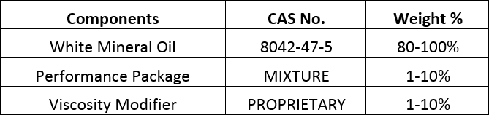

The exact percentage (concentration) of composition has been withheld as a trade secret. If CAS number is indicated as "PROPRIETARY" or "MIXTURE", information has been withheld as a trade secret.

First Aid - Inhalation

Move to fresh air and seek medical advice/attention if irritation develops. Artificial respiration and/or oxygen may be necessary.

Thoroughly rinse eyes and under eyelids with plenty of water for at least 15 minutes. Remove contact lenses if able to do so. Seek medical advice/attention if irritation develops.

First Aid - Eye Contact

Wash effected area immediately with plenty of water and soap for at least 15 minutes. Remove contaminated clothing and shoes and wash before reuse. Seek medical advice/attention if irritation develops.

First Aid - Skin Contact

Rinse mouth with water. Do not induce vomiting unless directed to do so by a physician or poison control center. Never give anything by mouth to an unconscious person. Seek medical advice/attention.

First Aid - Ingestion

Physicians should treat symptomatically.

Recommendations for immediate medical care/special treatment

Use extinguishing measures that are appropriate to local circumstances and the surrounding environment.

Suitable extinguishing media

No information available.

Unsuitable extinguish- ing media

**SECTION 5: FIREFIGHTING MEASURES**

**SECTION 4: FIRST AID MEASURES**

**SECTION 3: COMPOSITION/INFORMATION ON INGREDIENTS**

Cool closed containers exposed to fire with water spray.

Specific hazards that may develop when chemical burns

Special firefighting equipment/precautions

Firefighters should use all standard protective equipment to fight fire. Empty containers contain residue and/or vapors; do not weld, cut, pressurize, braze, solder, drill, grind or expose to heat, spark or flame.

Use personal protective equipment and ensure adequate ventilation. Material can create slippery conditions.

Personal precautions

In the event of a spill, evacuate non-essential personnel, remove any sources of ignition, ventilate spill area, and prevent entry into sewers and waterways. Pick up free material for recycle or disposal and absorb residual liquid with inert material.

Emergency procedures

Prevent further leakage or spillage if safe to do so. Soak up with inert absorbent material and remove any ignition sources. Use only non- sparking tools and ensure adequate ventilation. Notify the proper authorities.

Methods and material for containment

Dam up, then soak up with absorbent material. Use a dry spill kit or sand, and collect in appropriate containers before disposing according to all proper regulations. Clean contaminated surfaces thoroughly.

Cleanup procedures

Ensure adequate ventilation to prevent inhalation of vapor/dust or wear suitable respiratory equipment. Keep away from heat and sources of ignition. Avoid contact with skin, eyes and clothing. Do not smoke, eat or drink in application area.

Precautions for safe handling

Store in a dry, cool, well-ventilated area in original container. Carefully reseal opened containers and store upright to prevent leakage. To maintain product quality, do not store in heat or direct sunlight.

Storage recommen- dations

Exposure Limits

Contains no substances with occupational exposure limit values.

Engineering controls

No special ventilation requirements. Good general ventilation should be sufficient to control worker exposure to airborne contaminants.

Recommended Personal Protective Equipment:

If exposure to airborne mist or splashing is possible, safety goggles or safety glasses with side shields are recommended.

Eye/Face Protection

**SECTION 8: EXPOSURE CONTROLS/PERSONAL PROTECTION**

**SECTION 7: HANDLING AND STORAGE**

**SECTION 6: ACCIDENTAL RELEASE MEASURES**

Respiratory Protection

In case of mist, spray or aerosol exposure, wear suitable personal respiratory protection.

Skin/Body Protection

Oil resistant gloves are recommended. Appropriate body protection should be selected based on activity and possible exposure. Specific local conditions under which the product is used should also be taken into consideration.

Appearance

Amber liquid

Odor

Mild odor

Odor Threshold

Not available

pH

Not available

Melting Point/ Freezing Point

Not available

Initial Boiling Point/ Range

Not available

>505o F (>260o C)

Flash Point

Evaporation rate

Not available

Flammability

Low fire hazard.

This material must be heated before ignition will occur.

Flammability, upper limits

Not available

Flammability, lower limits

Not available

Vapor pressure

Not available

Vapor density

Not available

Relative density

Not available

Solubility(ies)

Not available

Solubility in water

Insoluble

Partition coefficient: n-octanol/water

Not available

Auto-ignition tempera- ture

Not available

Decomposition temp-

Not available

**SECTION 9: PHYSICAL AND CHEMICAL PROPERTIES**

erature

Viscosity @ 40oC, cSt

320

Reactivity

This product is stable and non-reactive under normal conditions of use, storage, handling and transportation.

Stability

This product is chemically stable under normal conditions of use, storage, handling and transportation.

Possibility of hazard- ous reactions

Hazardous polymerization does not occur.

Conditions to avoid

Not available

Incompatible mater- ials

Reactive with oxidizing agents.

Hazardous decomp- osition products

May release COx, smoke and irritating vapors when heated to decomposition.

***Potential health effects:***

Inhalation

Health injuries are not known or expected under normal use. Excessive inhalation of mist may result in respiratory irritation.

Not expected to to pose health issues for the eye.

Eye contact

Skin contact

Prolonged or excessive contact with skin may result in mild irritation, however, significant health injuries are not expected under normal use.

Ingestion

Health injuries are not known or expected under normal use. Overexposure may cause gastrointestinal disturbance.

***Symptoms or effects, including acute and delayed:***

Inhalation

Eye Contact

None known or expected under normal use.

None known or expected under normal use.

None known or expected under normal use.

Skin Contact

None known or expected under normal use.

Ingestion

**SECTION 11: TOXICOLOGICAL INFORMATION**

**SECTION 10: STABILITY AND REACTIVITY**

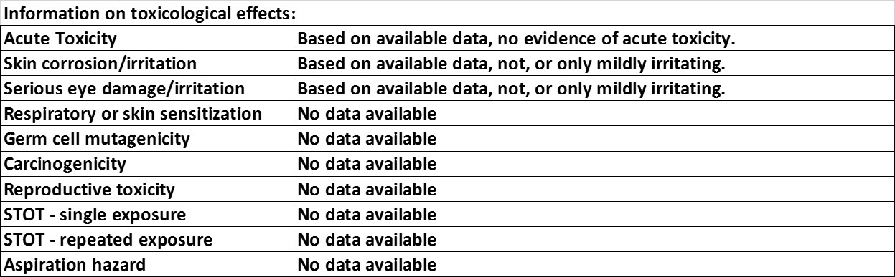

Toxicological effects:

NTP Report on Carcinogens

This product is not considered to be a carcinogen by NTP.

IARC listing of potential carcinogens

This product is not considered to be a carcinogen by IARC.

OSHA listing of potential carcinogens

This product is not considered to be a carcinogen by OSHA.

Biodegradability, OECD 301B

Not available

Bioaccumulation

Not available

OECD 201

Alga, EC50, 72hr, mg/L

Not available

OECD 202

Daphnia, EC50, 48hr, mg/L

Not available

OECD 203

Fish, LC50, 96hr, mg/L

Not available

Disposal consider- ations

Dispose of contents/container in accordance with all local, regional, state, national and international regulations.

**SECTION 13: DISPOSAL CONSIDERATIONS**

**SECTION 12: ECOLOGICAL INFORMATION**

Do not allow product to enter drains, water or soil. Classify and label waste before disposal at a licensed waste management company. Dispose of in accordance with all local, regional, state, national and international regulations.

Waste from residues/ unused products

Contaminated packaging

Empty containers may contain residue and should not be reused. They should be decontaminated and taken for local recycling, recovery or waste disposal.

US DOT

Not regulated by the US DOT as a hazardous material

TDG (Canada)

Not regulated by the Canadian TDG as a hazardous material

ADR

Not regulated

IMDG

Not regulated

IATA

Not regulated

US TSCA Inventory

All components of this product are either listed on the TSCA Inventory or are in compliance with the TSCA Inventory.

California Prop. 65

Not listed

SARA Extremely Hazardous Sub- stances

SARA Section 313

Not listed as such

Does not contain any 313 ingredients

CERCLA Hazard- ous Substances

No reportable quantity for this product or its components

**SECTION 15: REGULATORY INFORMATION**

**SECTION 14: TRANSPORT INFORMATION**

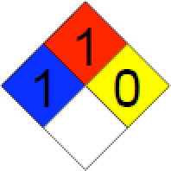

Revision date

1/1/2023

This product's safety information is provided to assist our customers in assessing compliance with safety, health and environmental regulations. The information contained within this document is based on data available to us and is believed to be accurate at the time of last revision. However, no warranty of use or any other warranty is expressed or implied regarding the accuracy of this data, the results to be obtained from the use thereof, or the hazards connected with the use of this product. Whereas the use of this product is within the exclusive control of the user, it is the user's obligation to determine the conditions for safe use of this product. Such conditions must comply with with all regulations concerning this product. BioBlend Renewable Resources, LLC assumes no liability for any injury or damage, direct or consequential, resulting from the use of this product unless such injury or damage is attributable to gross negligence on the part of BioBlend Renewable Resources, LLC.

**SECTION 16: OTHER INFORMATION**